Process for joining HPMA Extract Layer with TRN_street

Author: Ken Larade
Last edited: 27/11/2019

Require Inputs:
- HPMA Extract Feature Class from Scott Oxner (There is a ticket to create a new SDE feature class of the HPMA extract, once this is created, this should become the new data source for this information).
- TRN_street

Workspace:
I conducted the analysis in a local file geodatabase using a copy of the inputs.

Process:
- Create a new file geodatabase, adding a copy of TRN_street and the HPMA Extract.
  - Note: the extract from Scott may require a reprojection, as I believe the HPMA system is referencing the ATS77 projection.
  - Data objects in SDE have a projection of NAD_1983_CSRS_2010_MTM_5_Nova_Scotia.

- Create a new ArcMap document and add the inputs to the document.

- Create a new feature class that is a subset of TRN_street that contains only HRM owned roads and Non-Accepted Streets, and where all Turning Lane segments are excluded from future analysis. (HPMA does not rate roads that are not maintained by HRM or turning lanes.
  - Create a selection set of TRN_street where OWN = ‘HRM’ OR OWN = ‘NA’.
  - Next, remove from the current selection set where FLAGS IN ( 'TL' , 'TL ZAG' , 'TL UIMSR' , 'RNV TL', 'NRR TL', 'NAR TL ZAG', 'GSA NRR TL', 'GNP TL', 'DSN TL')
  - Save the selection as a new feature class called TRN_street_HRMandNA_noTLflag

- Use the Generate Points Along Lines Tool to create new point feature classes that contain the midpoint of the HPMA extract lines and the subset of TRN_street created in Step 3.
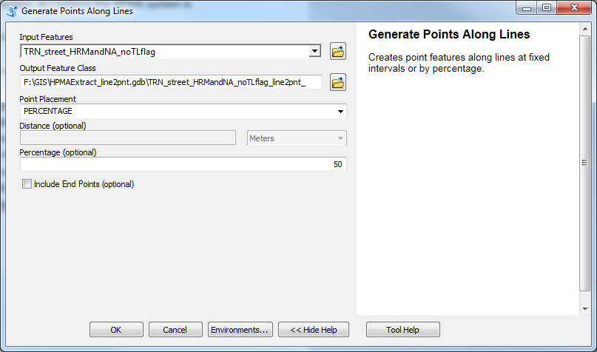

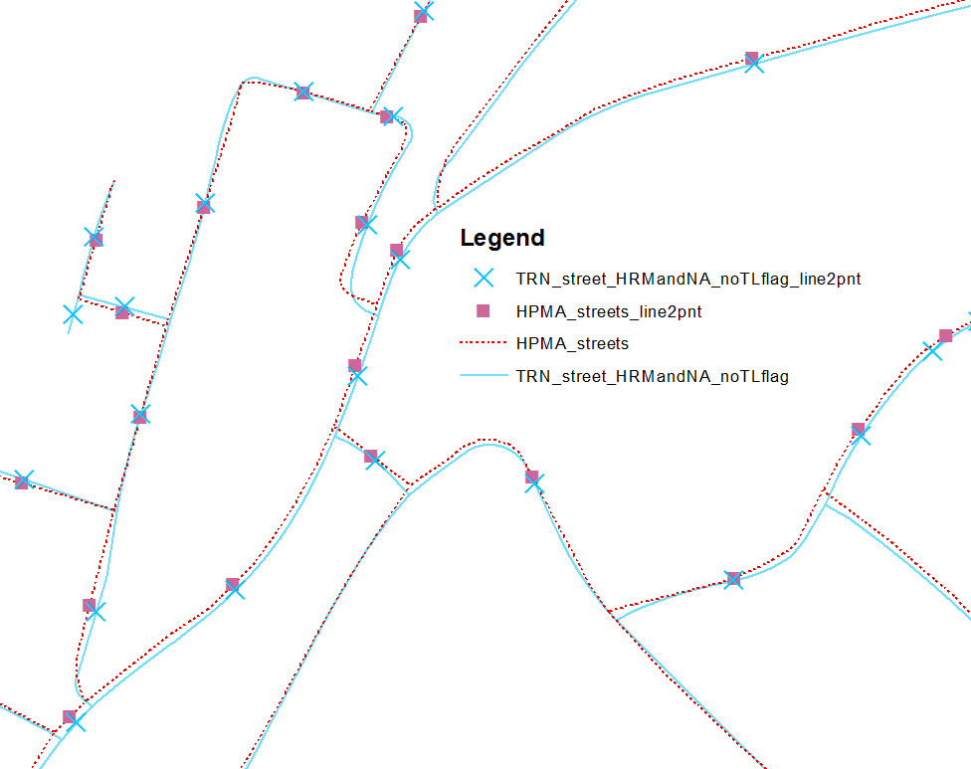

- Run a Spatial Join with the new point feature classes created in Step 4. Use a buffer distance of 10m.

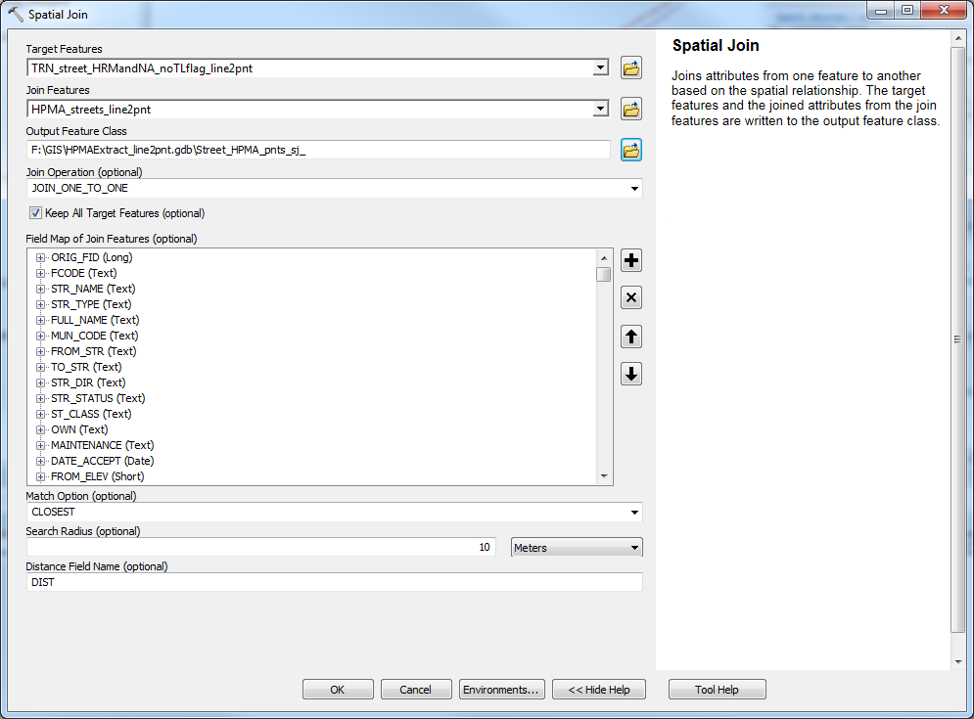

The output of this Spatial Join will be all the subset of street segments from TRN_street and if there is a HPMA centre point within 10m of a Street centre point that information will be included.

A new table could be created from the output of the spatial join that could consist of the FDMID and whichever attributes from HPMA that are of interest. That table could then be joined to TRN_street for future analysis.

